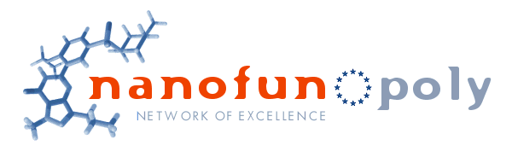

International Seminar on

Nanomaterials - Simulations and Experiments

Technical University of Lodz
Faculty of Chemistry
DEPARTMENT OF MOLECULAR PHYSICS

Lodz - Poland
April 15-16, 2005

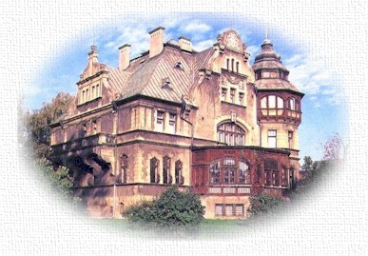

The Rector’s House of the Technical University of Lodz

Organized under the auspices of the Network of Excellence NANOFUN-POLY 6th FP European Community (http://www.nanofun-poly.net/)

Chaiman: Jacek Ulanski

First circular
January 2005
International Seminar on Nanomaterials - Simulations and Experiments
15-16 April 2005
Technical University of Lodz, Poland

Dedicated to Professor Marian Kryszewski for his 80 birthday

The aim of the Seminar is to present to PhD students and young researchers the modern trends in applications of simulations for modeling of different phenomena in nanomaterials and, when possible, to confront the results of simulations with experiments.

Full texts of the lectures will be published in a special issue of “Materials Science – Poland”.

The Seminar will be organised in a frame of NoE “NANOFUN-POLY”, but it will be open to all participants, also outside the NoE.

No registration fee, but participants should send registration form to Secretary of the Seminar, Agnieszka Slazak: aslazak@p.lodz.pl before end of March.

Place: Conference Hall in the building of Faculty of Chemistry, Technical University of Lodz, street Zeromskiego No 116, 90-924 Lodz, Poland.
The Seminar will start on Friday, 15. 04. 2005 at 10:00 am, and will continue on Sunday, 16. 04.

Preliminary list of speakers

L. Firlej, Universite Montpellier II
“Simulations of adsorption in cylindrical nanopores: the role of adsorbate-adsorbate interactions in stabilizing the adsorbed phase”

B. Kuchta, Universite de Provence, Marseille
“Melting transitions of monolayers adsorbed in cylindrical nanopores”

T. Pakula, Max-Planck-Institut fur Polymerforschung, Mainz, Germany, and Technical University of Lodz

“Modeling of Complex Polymers and Processes”

H. Galina, Rzeszow University of Technology
“Modelling of the feed and procedure of polycondensation as a method of controlling polydispersity in hyperbranched polymers”

J. K. Jeszka, Centre of Molecular and Macromolecular Studies of Polish Academy of Sciences and Technical University of Lodz
“MC Simulations of Polymer Flow in Confined Space"

P. Polanowski, Technical University of Lodz
“Some applications of DLL model for investigations of dynamic properties of complex and simple liquids”

G. Boiteux, Université Claude Bernard Lyon1
“Molecular relaxations in polyurethanes based on hyperbranched polyesters”

S. Nespurek, Institute of Macromolecular Chemistry, Academy of Sciences of the Czech Republic, Prague

“Metastable electronic states in polysilanes”

J. Sworakowski, Wroclaw University of Technology

"Transport and trapping of charge carriers along molecular wires - kinetic aspects"

A. Galeski, Centre of Molecular and Macromolecular Studies of Polish Academy of Sciences, Lodz “Competition of crystal plasticity and nucleation and growth of nanocavities in crystalline polymers during deformation”.

E. Piorkowska, Centre of Molecular and Macromolecular Studies of Polish Academy of Sciences, Lodz
”Crystallization of montmorillonite/polyolefin nanocomposites”

T. Kazmierczak, Centre of Molecular and Macromolecular Studies of Polish Academy of Sciences, Lodz
”New dislocation mechanisms of plastic deformation of crystalline polymers”

J. Ulanski, Technical University of Lodz
“Nanoheterogeneities in amorphous polymers as seen by Low frequency Raman spectroscopy”

Accommodation: there are different hotels not far from the conference place. Reservation could be made by fax or through the webpages :
ŚWIATOWIT * * *
http://www.hotelspt.com.pl/swiatowitpol.html
email:swiatowit@hotelespt.com.pl
tel. (+48-42) 636-36-37, 636-30-44, fax 636-52-91
90-432 Łódź, al. Kościuszki 68
weekend room rate: 179PLN/night

IBIS * *
http://www.ibishotel.com/ibis/fichehotel/gb/ibi/3096/fiche_hotel.shtml
tel. (+48-42) 638-67-00, fax. 638-67-77
90-368 Łódź, al. Piłsudskiego 11
weekend room rate: 175PLN/night

ALICJA * *
http://www.hotelsinpoland.com/alicja
tel. (+48-42) 648-76-04, tel./fax 684-63-70
93-590 Łódź, al. Politechniki 19a

Transportation: Lodz is easy accessible from the airports in Warsaw and in Poznan, also by trains from Germany and from Czech Republic.

Travel from/to the airport in Warsaw

Lodz is situated ca. 135 km west-south from Warsaw, where is the closest international Frederic Chopin Airport.

There is a direct connection from the airport in Warsaw to Lodz by coach "Polski EXPRESS", leaving the airport each two hours from 11:20 am to 19:20 pm (the travel takes ca. 2 h.). You can buy tickets in “ORBIS” travel office in the arrival hall or directly in the coach (ca. 32-35 PLN). The bus stop is situated in front of the arrival hall. In Lodz the bus stop is close to the Lodz-Fabryczna railway station. We recommend you to use the “Polski EXPRESS”.

To check your train connection from Warsaw to Lodz, please go to the web page of the Polish State Railways PKP: http://rozklad.pkpik.pl/bin/query.exe/ (ask for connection from "Warszawa Centralna" to “Lodz Fabr.”).
From the Frederic Chopin Airport to the railway station “Warszawa Centralna” you can go by taxi or by bus (line No. 175). Ticket you can buy in newspapers kiosk. Travel will take ca. 30 min.

From the railway station Lodz Fabr. you can reach your hotel by taxi. Call the free number 0800-6505050 for the taxi. The cost will be ca. 12 PLN from the railway station.

For the travel from Lodz to Warsaw we recommend you to use also the coach “Polski EXPRESS”, leaving Lodz each two hours from 8 am to 4 pm.

Registration form, maps and information on hotels and transportation will be also available on www pages of NoE NANOFUN-POLY: www.nanofun-poly.com and TUL: http://www.p.lodz.pl/k-32

============================
If you have any problems with your travel, hotel reservations or any other questions or request, please do not hesitate to contact me:
Agnieszka Slazak
Tel.: +(48-42) 631-32-05
Fax: +(48-42) 631-32-18
aslazak@p.lodz.pl

