Structural and Morphological Properties of ZnO films Obtained by Chemical Bath Deposition

V. Popescu^{1,2,#}, G. L. Popescu², M. Dănilă¹, A. Dinescu¹

¹National Institute for Research and Development in Microtechnologies, IMT, 077190 Bucharest, Romania.
²Technical University of Cluj-Napoca, 400641 Cluj-Napoca, Romania.

#Corresponding author: violeta.popescu@chem.utcluj.ro

Zinc oxide (ZnO) is a semiconductor that responds to ultraviolet (UV) light, having a wide band gap of 3.37 eV for bulk material, with various applications including light-emitting devices, solar cells, gas sensors being a promising material for short wavelength optoelectronic devices, especially for UV light-emitting diodes (LEDs) and laser diodes (LDs).
ZnO films have been deposited onto commercial glass slides by Chemical Bath Deposition starting from solutions containing ZnSO₄, NaOH and NH₄OH, at 80ºC. The influences of the deposition time and solution concentration on the formation and the properties of the films were studied.
X ray diffraction analysis revealed that the “as deposited” films consisted on well formed ZnO crystals (Fig 1). Thermal treatment (T) determined the increase of the crystallinity of the films. The deposition conditions influenced the growth directions, the density of the nanorods and the shapes of the crystals that formed the films (fig 2).
Fig.1. X ray diffraction patterns of as deposited and and thermal treated (T) films

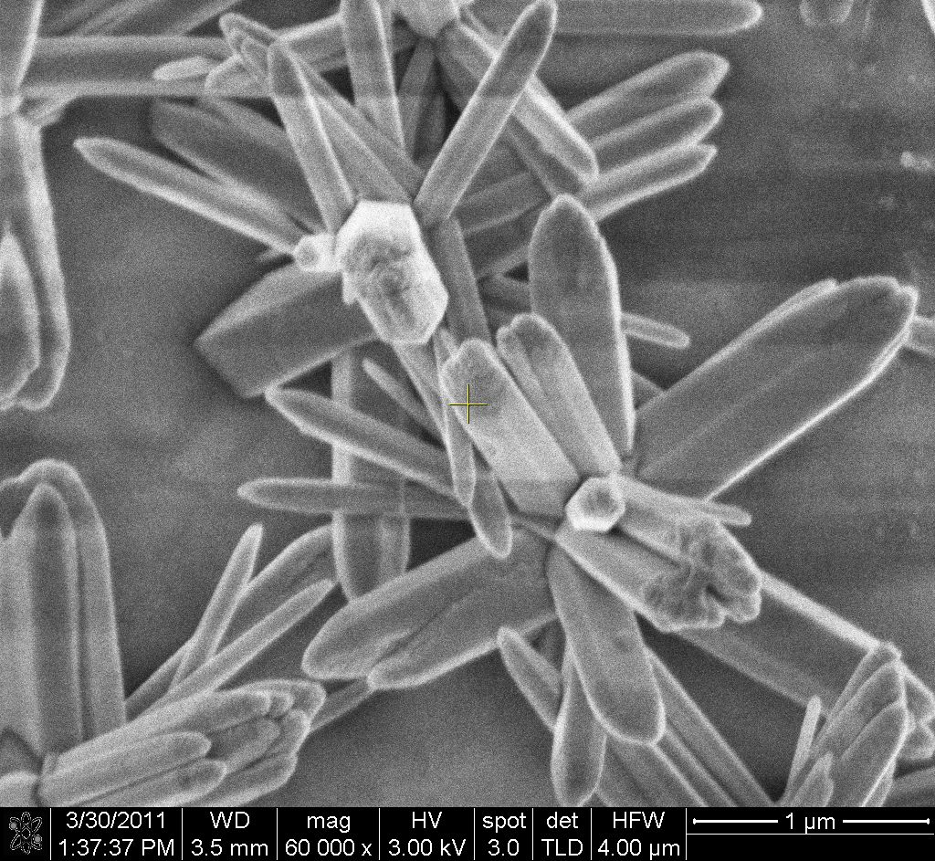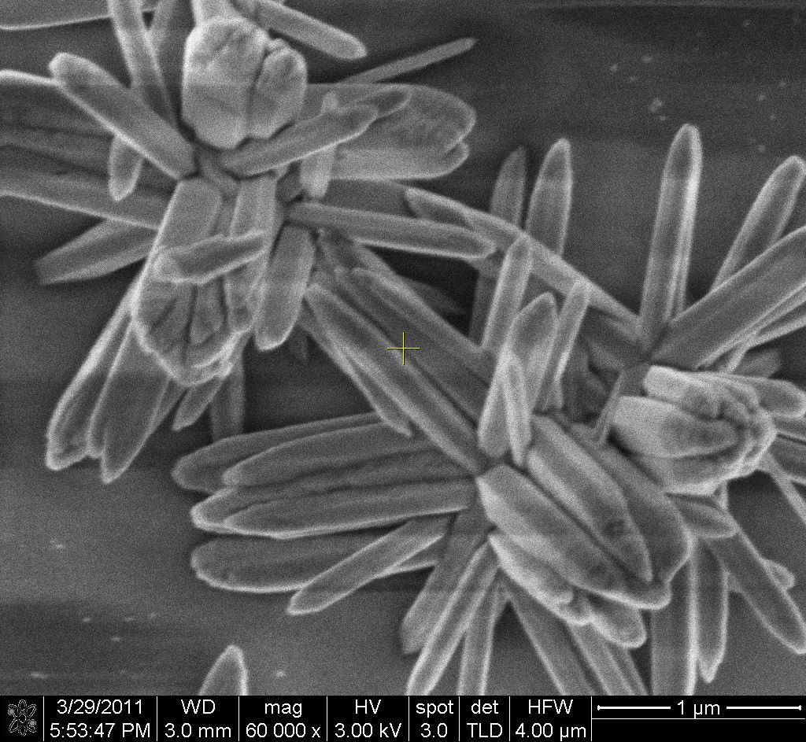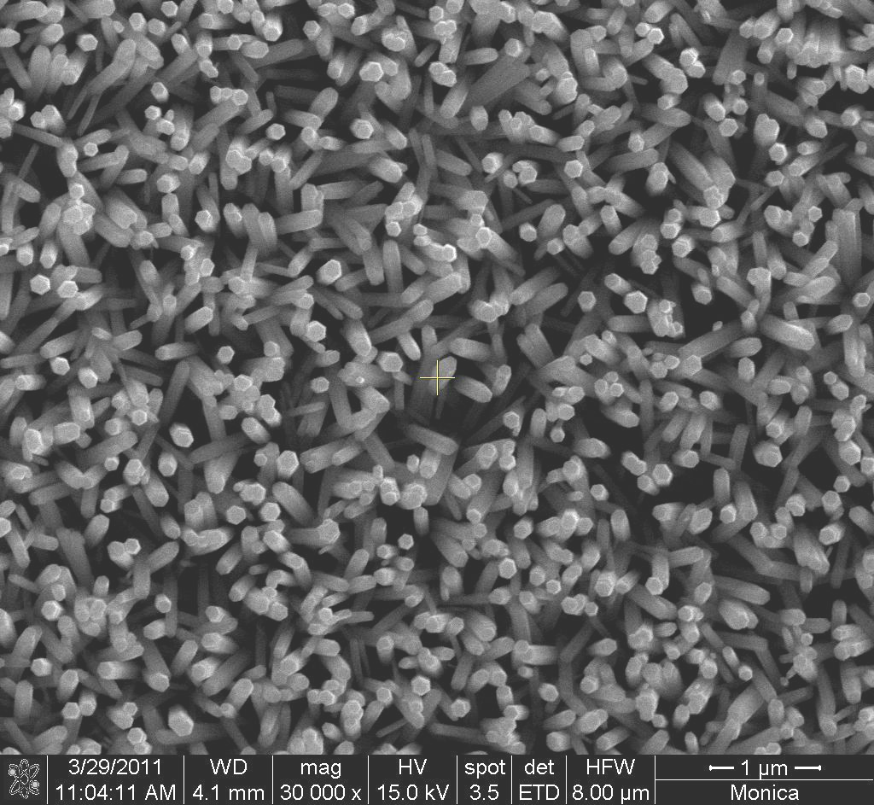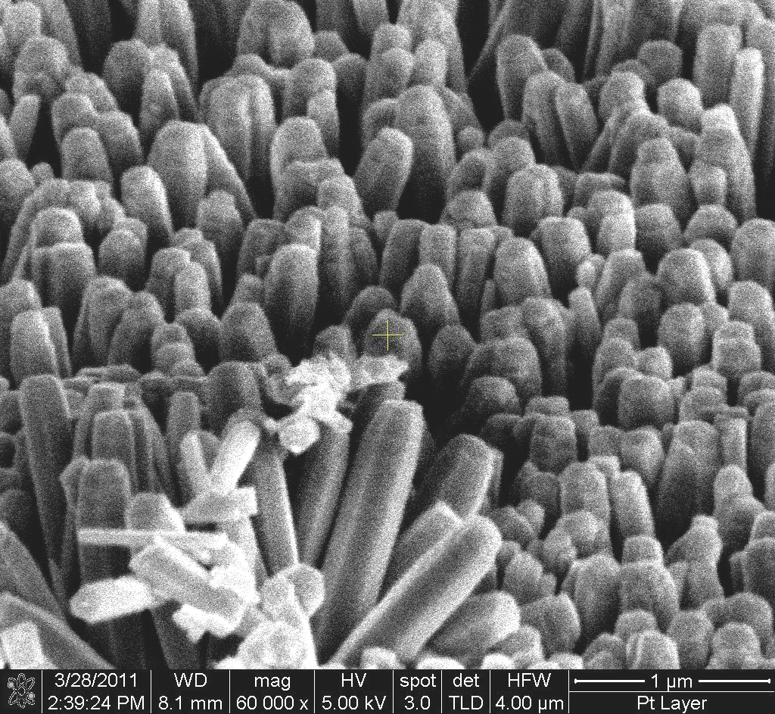
a. b. c. d.
Fig. 2. SEM micrographs of ZnO films a. sample 5, b. sample 6 T, c. sample 7, d sample 8.

Thermal treatments had a minor influence on the morphology of the films.

Acknowledgement
This paper was supported by the project "Human Resource Development by Postdoctoral Research on Micro and Nanotechnologies", Contract POSDRU/89/1.5/S/ 63700, project co-funded from European Social Fund through Sectorial Operational Program Human Resources 2007-2013.

