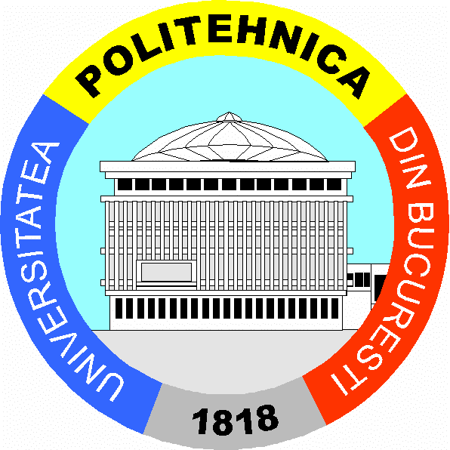
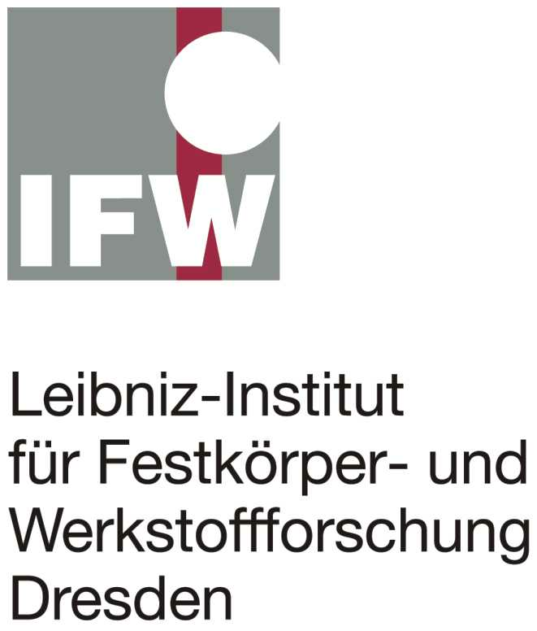
University ‘Politehnica’
of Bucharest

NANOSTRUCTURED MATERIALS
synthesis, characterization, functionality

Workshop

UP Bucharest (SIM Faculty) - IFW Dresden

Research Partnership financed
by Alexander von Humboldt Foundation

23-24 November, 2004
at the University ‘Politehnica’of Bucharest
Rectorat Building, AN 034

Bucharest / Romania



PROGRAM
German Guests:

- From IFW Dresden (Leibniz Institute for Solid State and Materials Research Dresden) :
- Rolf Pfrengle (Director IFW Dresden)
- Prof. Ludwig Schultz (Director IMW -Inst. for Metallic Materials- IFW Dresden)
- Dr. Annett Gebert (Head of Electrochemical Properties of Functional Materials Dept.)
- Dr. Bernd Rellinghaus (Head of Metastable and Nanostructured Materials Dept.)
- Dr. Rudi Schäfer (Head of Magnetic Microstructures Dept.)
- Mihaela Rada (PhD Student)

- From TU Darmstadt (Technical University Darmstadt):
- Prof. Jürgen Eckert (Head of Physical Metallurgy Chair, Faculty of Materials Science)

Monday, 22 November 2004

Arrival of Guests

19:00 Welcome Dinner

Tuesday, 23. November 2004 (AN 034-Rectorat)

09:00 Opening Remarks:
Prof. Serban Raicu – Vice-Rector for scientific research (UP Bucharest)
Prof. Gheorghe Marian - Vice-Rector for international relations
Prof. Rami Saban - Dean of Faculty of Materials Science and Engineering (SIM)

09:30 Short presentation of UP Bucharest (SIM Faculty) - IFW Dresden research partnership financed by Av Humboldt Foundation
Assoc.Prof. Mariana Calin (UP Bucharest)

09:45 “German Research Landscape”
Rolf Pfrengle (Director of IFW Dresden)

10:15 “Flying on Magnetic Fields - High temperature superconductors for magnetic levitation”
Prof. Ludwig Schultz (Director of IMW- IFW Dresden)

10:45 Coffee Break

11:00 “Magnetic microstructure of nanocrystalline materials”
Dr. Rudi Schäfer (IFW Dresden)

11:25 “Magnetism, structure and phase stability of FePt nanoparticles"
Dr. Bernd Rellinghaus (IFW Dresden)

11:50 “Beginnings and evolution of researches on metastable structures, including nanomaterials, at the Department of Materials Science & Physical Metallurgy, Faculty of Materials Science and Engineering”
Prof. Maria Petrescu, Prof. Nicolae Petrescu (UP Bucharest)

12:15 Lunch Break

13:15 Visits in the laboratories of the Faculty of Materials Science and Engineering (Coffee Point included)
14:15 “Dimension of technical high education in foreign languages at UP Bucharest”
AN 034 Prof. Adrian Volceanov (Vice-Dean of the Faculty of Engineering Taught in Foreign Languages), Prof. Sergiu Iliescu (German Dept.), Assoc.Prof. Cristian Dragomirescu (German Dept., Scientific Secretary of Faculty)

14:40 “Nano-Scale Surface Engineering and Characterization”
Dr. Liliana Dumitrescu-Buforn (University of Applied Sciences - EIAJ
Department of Microtechnology, Le Locle, Switzerland)

15:00 “FP6 EU-Projects opportunities in Nanomaterials & Nanotechnologies field”
Prof. Aurelia Meghea (UP Bucharest)

15:20 Roundtable-Discussion: “Scientific Research at the Faculty of Materials Science and Engineering - SIM” (UP Bucharest)
Dean and Vice-Deans of SIM: Prof. Rami Saban, Prof. Cezar Balescu, Assoc. Prof. Pavel Toboc
Heads of Departments of SIM: Prof. Georgeta Cosmeleata, Prof. Petru Moldovan, Prof. Iulian Riposan; and Prof. C.Dumitrescu
Heads of Research Centres of SIM: Prof. Daniel Bunea, Prof. Nicolae Constantin, Prof. Cristian Predescu

15:50 Visit to Palace of Romanian Parliament, Bucharest

19:30 Dinner (Romanian Cuisine Restaurant)

Wednesday, 24. November 2004 (AN 034-Rectorat)

09:00 “Nanostructured composite materials with improved mechanical properties”
Prof. Jürgen Eckert (TU Darmstadt)

09:30 “Quantum transport in Si-based nanosystems”
Prof. Magdalena Ciurea (INFM Bucharest)

09:55 “Corrosion of nanostructured and glassy alloys”
Dr. Annett Gebert (IFW Dresden)

10:20 Coffee Break

10:40 “Nanostructured and amorphous non-ferrous alloys”
Assoc.Prof. Mariana Calin (UP Bucharest)

11:00 “Corrosion of nanocrystalline Nd-Fe-B magnets”
Mihaela Rada (IFW Dresden)

11:15 “Nanocrystallization kinetics from amorphous precursors”
Marius Adam (UP Bucharest)

11:30 Roundtable-Discussion: “Collaboration opportunities and plans for future interactions” (Room JI 109, SIM Faculty)

12:15 Lunch Break

14:00 Sightseeing Tour of Bucharest

19:30 Symphonic Concert at Romanian Atheneum, Bucharest
---------
Workshop’s Organizing Team: M. Calin, M. Branzei, D. Gheorghe, M. Adam, M.Miculescu (SIM)

