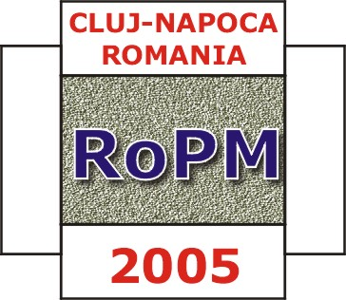

THIRD INTERNATIONAL CONFERENCE & EXIBITION ON POWDER METALLURGY

RoPM 2005

7-9 July, 2005

Technical University of Cluj-Napoca, ROMANIA
Tel: +40-264-401.705 Fax: +40-264-415.054

Conference web page : http://sim.east.utcluj.ro/RoPM2005

E-mail: liviu.brandusan@staff.utcluj.ro

06th January 2005

We are pleased to transmit you the following information related to RoPM 2005:

- Deadline for the abstracts submission has been extended to 21 January 2005. It is possible online at the above specified Conference web address. Please fill in all the requested information.

- Deadline for the announcement of abstract acceptance will be 31 January 2005.

- The Organizing Committee has the intention to organize this Conference at International Hotel in Sinaia, the pearl of the Carpathian Mountains, close to the Peles Castle & Museum (former Royal summer residence), Dracula Castle, Black Church in Brasov, Poiana Brasov.

- The participation fee (including welcome reception, accommodation at International Hotel and meals for all the Conference period, gala dinner and Conference Proceedings) will not exceed 200 - 300 Euro.

We would like to thank you for your contribution to the event.

Please do not hesitate to contact us for any kind of assistance.

Conference Organizing Committee

