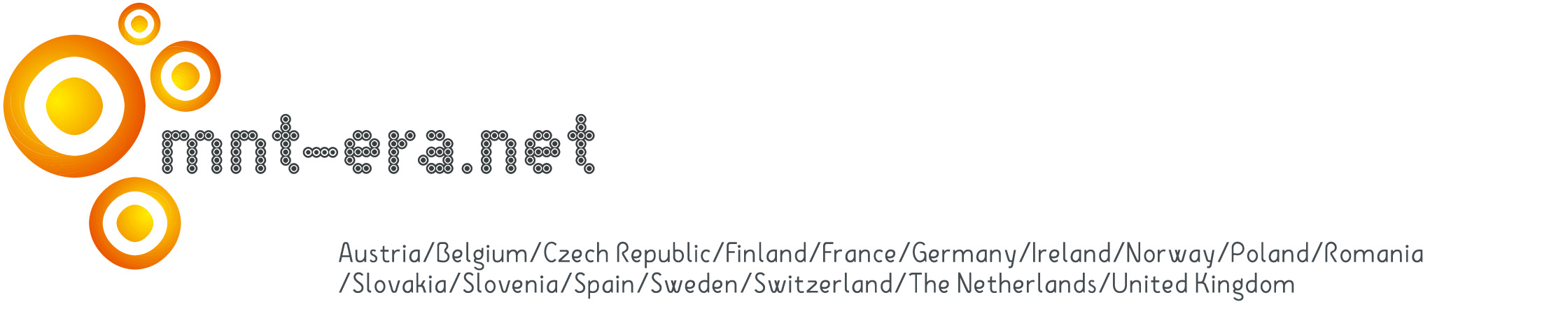
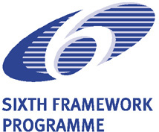



Topics Supported by MNT ERANET

Medical devices; Optical devices, Energy (energy storage, photovoltaic, fuel cells, batteries), Actuators and sensor, Instrumentation (AFM, holographic instruments, calibration); MEMS, MOEMS, NOEMS, NEMS, Manufacturing (machining, LIGA, nano lithography, nano structuring, nano tribology);
System integration; Materials (e.g. functionalisation, surface structuring, replication, composites); Nanoelectronics; Simulation and modeling , Nanobiotechnology (e.g. delivery systems, Lab-on-a-chip)

Meeting venue
NanoEurope • Olma Messen St. Gallen
Splügenstrasse 12 • CH-9008 St. Gallen
Phone +41 71 242 04 44 • Fax +41 71 242 01 03
Email: info@nanoeurope.com • www.nanoeurope.com
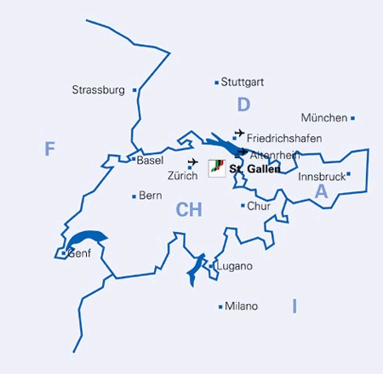
Arriving by car
Exit the national highway A1 at St. Gallen-St. Fiden and follow this symbol  plus the special parking instructions.
Arriving by train
From the Zurich Airport railway station (SBB), trains leave for the main station in
St. Gallen at half-hour intervals.
At St. Gallen, the bus station is just opposite the main railway station. Bus No. 3 (“Hauptbahnhof–Heiligkreuz”) leaves at 7-minute intervals. You can use it free of charge with your Conference Badge. Get off at stop No. 5, “Haltestelle Olma”
(traveling time about 5 minutes).
DRAFT 1

Invitation for
Entrepreneurs and Researchers
to

The Workshop for
European
Transnational Collaborations

Micro- and Nanoscale Science
to New Technologies for Europe

Swiss National Event
September 15th, 2005, 11:45 – 14:15h
Nano Forum,
NanoEurope 2005,
CH-9000 St. Gallen

http://www.mnt-era.net

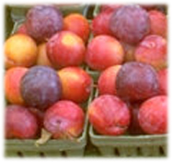

TEMAS AG • Egnacherstrasse 69 • CH-9320 Arbon
Phone +41 71 446 50 30 • Fax +41 71 446 50 82 • temas@temas.ch • www.temas.ch
0705/1

What is MNT ERANET?

The European Research Area has as its core message the need to overcome the traditional fragmentation of research efforts in the EU through better coordination and cooperation. Supporting the Cooperation and Coordination of Research Activities carried out at National or Regional Level.

Complementary to EUREKA, the scope of MNT ERA-NET is to enhance multinational European cooperation projects for Micro- and Nano Technology research and development. In distinction to EUREKA, it is designed to act through intensified direct cooperation in between support agencies and ministries.

Industry: Entrepreneurs looking for partners in highly dynamic economic regions of Europe for collaborations with outstanding research and market organizations.
Research: Research groups looking for collaborations with industries, mainly SMEs from dynamic regions of the EU.

For European Partners:  - Collaborations with Swiss Entrepreneurs and Companies at the technology and product level.  - Common research projects with fore front Swiss research groups in the fields of: Instrumentation, Sensors, Nano-Bio, Surfaces and Materials. | For Swiss Partners:  - Learn more about highly dynamic economic regions and the potential for collaborations.  - Common research projects with outstanding research groups from Europe and disciplines such as: Composites, polymers, thin films, encapsulation, structuring, simulation, optics

Agenda
11:45 - 11:55h Introduction and Process of MNT ERA NET K. Höhener
11:55 - 12:35h Presentation of Swiss Partners
Companies
- Nanosurf AG (Instrumentation) Dr. L. Scandella*
- Mecartex AG
(Ultrahigh Precision Metrology and
Mechatronic Systems) Dr. St. Bottinelli*
Research institutes
- EMPA, Material Science and Technology
(Materials, Textiles, Coatings, Surfaces)
Prof. L. Schlapbach*
- EPFL, Ecole Polytechnique Fédérale de Lausanne
(Biocapteur et membranes) Prof. H.Vogel*
12:35 - 13:35h Presentations of European partners
Economic regions
- CR Midi-Pyrenees (Toulouse/France)
Regional Council of Midi-Pyrénées to be defined
- Enterprise Ireland, CTO Nanotech to be defined
- The Economic Potential of Norway(?) to be defined
Research Centers
- Research Topics and Collaboration Opportunities
with Romania
(Functional polymeric materials,
Nanoparticles, thin films, Optics, …) to be defined
- NanoNet Styria (Austria)
(Nano Composites, Polymers, NanoBio) to be defined
- MHEST, Ministry of Higher Education and Science
Slovenia
(Biosensors, nano Structures, thin films) to be defined
13:35 - 14:15h Parallel workshop session with 10 speakers

Who should attend the St. Gallen Workshop?

The Topics of the St. Gallen Workshop?

