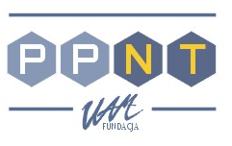 | ADAM MICKIEWICZ UNIVERSITY FOUNDATION  PoznaN SCIENCE AND TECHNOLOGY PARK

FP6 Regional Contact Point, Rubież 46, 61 - 612 Poznań, Poland, tel.: (+48 61) 8279 745, fax.: (+48 61) 8279 741

R e g i s t r a t i o n f o r m

Life Sciences – let’s join the European Research

Last call for proposals in the FP6

29th-30th September 2005, 09h00 – 15h00
Poznań University of Medical Sciences. Collegium Stomatologicum
Bukowska 70 Street, room 205, Poznań, Poland

1. Title | 2. First name | 3. Name

3. Institution

4. Address

5. Phone | 6. Fax

7. E-mail

I will participate in the Information Day – September, 29th (Thursday)

I will participate in the workshop – September, 30th (Friday)

Participation is free of charge.

Filled form please send to us by 26/09/2005
Address: Poznan Science and Technology Park, Att. Ewa Kocinska
Rubież 46, PL 61-612 Poznan, POLAND
fax. +48 61 8279741, e-mail: ewa.kocinska@ppnt.poznan.pl

