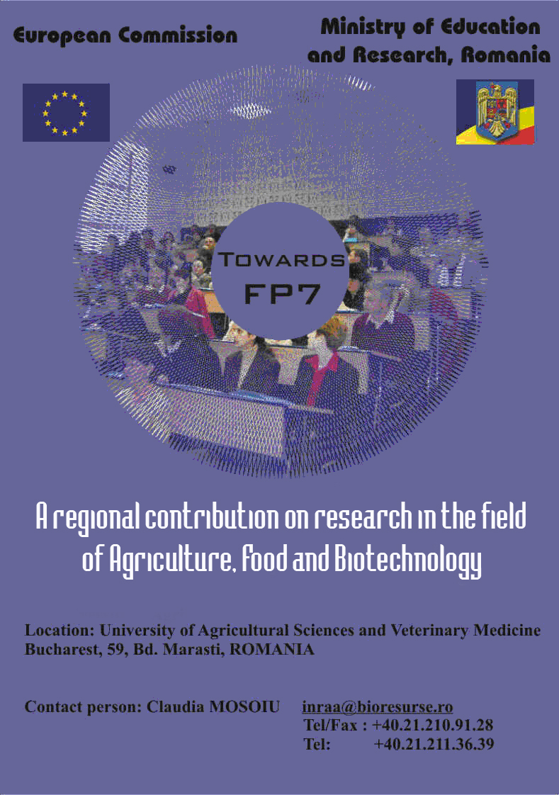

29th-30th November, 2005

The Balkan region includes Member States, Accessing Countries, Candidate Countries and Third Countries and has a great potential in the field of food, agriculture and biotechnology, both in research and economic related sectors. All these countries share a common heritage regarding specific foods, traditional production methods, and nutritional habits.

The conference "Towards FP7 - A regional contribution on research in the field of agriculture, food and biotechnology” aims to bring together scientists, experts from industry and other stakeholders, from the Balkan region and from other European areas, in order to exploit new and emerging research opportunities that address social, economic and environmental challenges in food, agriculture, forestry, aquaculture, and fisheries, including biotechnological aspects.

The conference will provide a timely forum for discussing and highlighting opportunities and specific themes of interest to be jointly developed in view of potential co-operation within FP7. It will be as well benefit to the scientific community, consumers and authorities both from the EU and the Balkan region to exchange views and ideas for the improvement of mutual understanding.

Within the 7th Framework Programme, research in the field of food, agriculture and biotechnology will have important contributions to deliver in terms of innovations and will provide policy support for building and developing a European Knowledge Based Bio-Economy.

The research will focus on the sustainable management, production and use of biological resources, and the convergence with other technologies, to provide new, eco-efficient and competitive products from European agriculture, fisheries, aquaculture, food, health, forest based and related industries.
Research will make important contributions to the implementation and formulation of European Union policies and regulations and will seek to develop new and existing indicators supporting analysis, development and monitoring of these policies.
Agro-food industries will particularly benefit from many research activities, including targeted dissemination and technology transfer activities.
Several European Technology Platforms, covering the areas of plant genomics and biotechnology, forestry and forest based industries, global animal health, farm, animal breeding, food, aquaculture and industrial biotechnology and contribute in setting common research priorities for this theme.
The international scientific cooperation policy of the EU will stress and develop cooperation to generate, share and use knowledge through equitable research partnerships. The actions will support fulfilling international commitments of the EU and contribute to sharing European values, competitiveness, socio-economic progress, environmental protection and welfare under the umbrella of global sustainable development.

AGENDA 29.11.2005
Registration of the Participants | 9.00 – 9:30
Opening addresses  Chair: IULIA MIHAIL – Department of European Integration and International Cooperation - National Authority for Scientific Research  ALECU IOAN – University of Agricultural Sciences and Veterinary Medicine, Bucharest  PETRU NICULITA - University of Agricultural Sciences and Veterinary Medicine, Bucharest  CRISTIAN HERA – Academy of Agricultural and Forestry Sciences | 9:30 – 10:00
Knowledge Based Bio-Economy – Perspective for food, agriculture and biotechnology  CHRISTIAN PATERMANN, European Commission, DG RTD, Director of “Biotechnology, Agriculture and Food” Directorate | 10:00 – 11:00
Coffee Break | 11.00 – 11.30
Technology Platforms in the field of food, agriculture and biotechnology  ANTONIO DI GIULIO European Commission, DG RTD, Directorate “Biotechnology, Agriculture and Food”, Head of “Food Quality” Unit | 11:30 – 12:00
Lunch | 12:00 – 13:00
Chair: ROMEO ILIE – Romanian Academy - Bucharest

Regional contribution to research on:
- Sustainable production and management of biological resources from land, forest and aquatic environments;
- “Fork to farm”; Food, health and well being;
- Life sciences and biotechnology for sustainable non-food products and processes.
Turkey- GUNER OZAY, Marmara Research Centre | 13:00 – 13:30
Bulgaria - ATANAS ATANASSOV, AgroBioInstitute | 13:30 – 14:00
Croatia  VLASTA PILIŽOTA, Faculty of Food Technology,  “ J. J. Strosmayer” University in Osijek | 14:00 – 14:30
Coffee Break | 14:30 – 15:00
Albania  TATJANA DISHNICA, Research and Extension Service in the Ministry of Agriculture and Food | 15:00 – 15:30
Serbia – Montenegro  SLAVOLJUB VITOROVIC, Faculty of Agriculture, Department of Pesticides, University of Belgrade | 15:30 – 16:00
Romania  NASTASIA BELC- Institute of Food Bioresources | 16:00 – 16:30
Interactive discussions  End of the 1st day of debate | 16:30 – 17:30

AGENDA 30.11.2005
Chair: MONA POPA ELENA- University of Agricultural Sciences and Veterinary Medicine, Bucharest

Regional contribution to research on:
- Sustainable production and management of biological resources from land, forest and aquatic environments
- “Fork to farm”; Food, health and well being
- Life sciences and biotechnology for sustainable non-food products and processes
Hungary  DIANA BANATI – Central Food Research Institute | 9:00 – 9:30
Bosnia – Herzegovina - the speaker will be confirmed | 9:30 – 10:00
Former Yugoslav Republic of Macedonia (FYROM)  VLADIMIR KAKURINOV, Faculty of Agricultural Sciences and Food | 10:00 – 10:30
Coffee Break | 10:30 -11:00
Slovenia  PETER RASPOR, University of Ljubljana, Biotechnical Faculty. | 11:00 – 11:30
Greece - Nikolaos KATSAROS, National Center of Scientific Research "Demokritos" | 11:30 – 12:00
Lunch | 12:00 – 13:00
Chair: PETRU NICULITA – University of Agricultural Sciences and Veterinary Medicine, Bucharest

What is International cooperation?  ELISABETA BALZI European Commission, DG RTD, Directorate “Biotechnology, Agriculture and Food”, Scientific Officer within “Food Quality” Unit | 13:00 – 13:30
Brainstorming and partnering event | 13:30 – 15:30
Conclusions  IULIA MIHAIL – Director for International co-operation, National Authority for Scientific Research  End of the event | 15:30 -16:30

 | 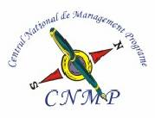
 | 
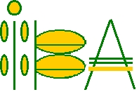



Organization Committee

Iulia Mihail – National Authority for Scientific Research
Maria Spulber – European Commission- DG Research, Directorate E-Biotechnology, Agriculture and Food Research Unit E2-Food
Mircea Sbarna - Romanian Mission in Brussels
Serban Panaitescu – National Centre for Programs Management
Petru Niculita – University of Agricultural Sciences and Veterinary Medicine
Cristian Hera – Academy of Agricultural Sciences and Forestry
Dan Dascalu – National Institute for Research and Development in Microtechnologies
Razvan Teodorescu - National Authority for Scientific Research
Nastasia Belc – Institute of Food Bioresources
Mona Popa – University of Agricultural Sciences and Veterinary Medicine
Cristian Kleps - Academy of Agricultural Sciences and Forestry
Gheorghe Mencinicopski – Company for Applied Research and Investments SA
AneMari Marcusanu – Chamber of Commerce and Industry of Romania and Bucharest
Carmen Moldovan – National Institute for Research and Development in Microtechnologies
Claudia Enoiu Roman - National Institute for Research and Development in Microtechnologies
Gabriela Nedita - Institute of Food Bioresources
Maria Enoiu – Institute of Food Bioresources
Simac Viorel - Institute of Food Bioresources
Alexandru Stancov - Institute of Food Bioresources
Romeo Ilie – Romanian Academy
Claudia Mosoiu – Institute of Food Bioresources

