LOCATION
Faculty of Chemistry
University of Bucharest
Blvd. Regina Elisabeta nr. 4 – 12,
030018 Bucharest, Romania

CONFERENCE PROGRAM

Includes:

Invited plenary lectures (45 minutes)
Keynote lectures within sections
(30 minutes)
Oral presentations within sections
(15 minutes)
Posters (A0 portrait format)

The official language of the Conference is English.

PUBLICATIONS

All abstracts of contributions will be submitted to the Scientific Committee. Only those included in the Conference program will be published in volumes distributed to the participants.
Several issues of Revue Roumaine de Chimie will be made available for publishing of the extended papers submitted within the peer reviewed system.

Online information at:

http://romphyschem.icf.ro/romphyschem.html
INFORMATION FOR
CONTRIBUTORS
Communications submitted to the Conference must contain results of basic, advanced and applied studies.

All contributions must be original and not published at the time of the Conference.
In order to receive the Second Announcement, please fill in the Participation Form and post, fax or e-mail it before January 15, 2006 to:
Institute of Physical Chemistry
The Organizing Committee of the International Conference of Physical Chemistry
Splaiul Independentei no. 202
Bucharest-060021, ROMANIA,
PO BOX 12-194,
Fax. +4021 3121147
Tel. +4021 3163101
E-mail: romphyschem@icf.ro

Information concerning registration fee, accommodation and other organizing matters is available on the web site

Deadlines:
February 15, 2006, registration and submission of abstracts
April 15, 2006, e-mail notified acceptance of papers
August 1, 2006, conference program.

The Organizing Committee is looking forward to meet you in Bucharest.
INVITATION

The Organizing Committee invites you to join:

The International Conference of Physical Chemistry

ROMPHYSCHEM-12

CONFERENCE SECTIONS

Theoretical chemistry. Molecular structure and spectroscopy.
Chemical kinetics. Photochemistry.
Radiochemistry.
Chemical thermodynamics.
Adsorption and heterogeneous catalysis.
Electrochemistry. Ionic liquids.
Corrosion and corrosion protection.
Physical chemistry of colloids and
macromolecules.
Physical chemistry of materials.
Chemical engineering.
Biophysical chemistry.
Physical chemistry of the environment.
Physico-chemical analysis.

Special Symposiums:

Fluid Phase Equillibria.
Sol-Gel Science and Technology.
Oscillatory Reactions.
Magnetochemistry.

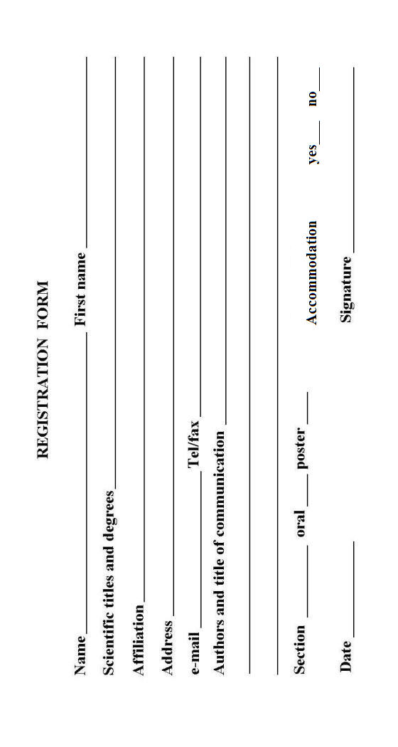

ORGANIZING COMMITTEE

Chairman: Prof. Victor E. Sahini
(Member of the Romanian Academy)
Scientific secretary: Prof. Eugen Segal
(CM of the Romanian Academy)

Members:
Dr. Niculae I. Ionescu
Dr. Gabriel Munteanu
Dr. Mircea Olteanu
Dr. Mihai V.Popa
Dr. Vlad T. Popa
Dr. Speranta Tanasescu
Dr. Maria Zaharescu
(CM of the Romanian Academy)
Prof. Cristina Mandravel
Prof. Tatiana Oncescu
Prof. Dumitru Oancea
Prof. Elena Volanschi

Conference Secretariat:
Dr. Alexandra Barau
Dr. Virgil Constantin
Dr. Tatiana Pascu
Dr. Bogdan Jurca
Dr. Valentina Chiosa
Drd. Cristian Hornoiu
Tech. pr. Aurelia Chelaru

INTERNATIONAL CONFERENCE
OF
PHYSICAL CHEMISTRY

- ROMPHYSCHEM 12 -

September 6-8, 2006

Bucharest, ROMANIA

Organizers:

INSTITUTE OF PHYSICAL CHEMISTRY “ILIE MURGULESCU” OF THE ROMANIAN ACADEMY

DEPARTMENT OF PHYSICAL CHEMISTRY, FACULTY OF CHEMISTRY, UNIVERSITY OF BUCHAREST

ROMANIAN CHEMICAL SOCIETY,
SECTION OF PHYSICAL CHEMISTRY

- First Announcement -

