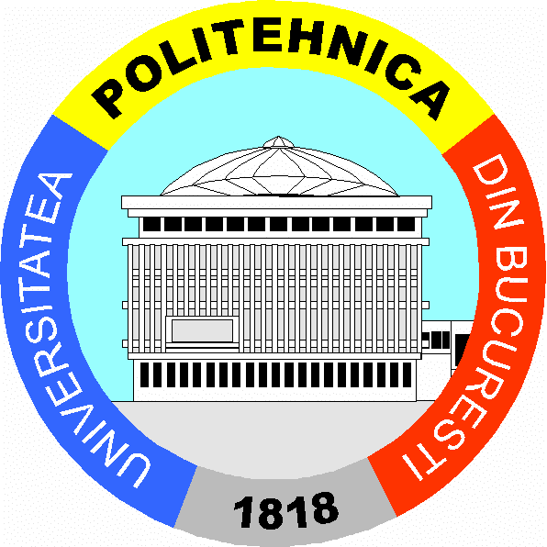
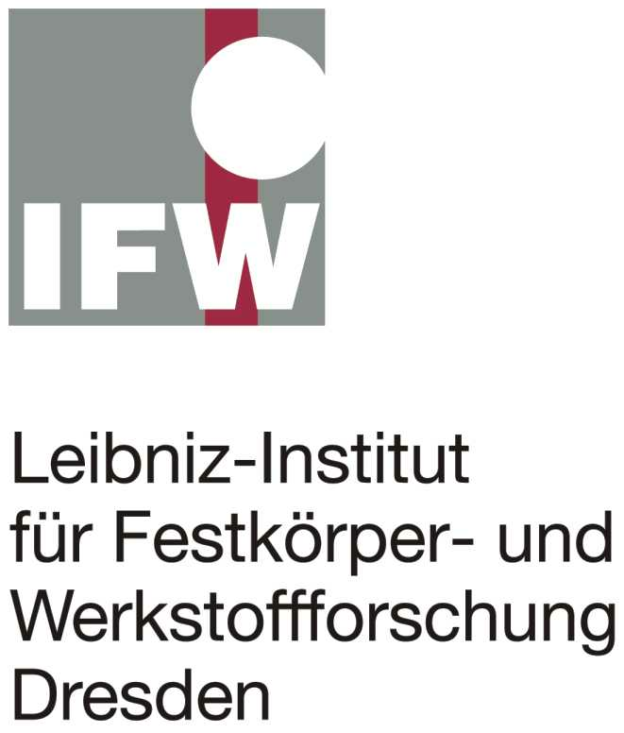
University ‘Politehnica’
of Bucharest

MATERIALS DEVELOPMENT
ON THE NANOSCALE

Romanian - German Workshop

UP Bucharest - IFW Dresden

Research Partnership financed
by Alexander von Humboldt Foundation

26-27 October 2006

University POLITEHNICA of Bucharest
Senate Hall, R 101

Bucharest / Romania

PROGRAM

Thursday, 26. October

9:30 Opening Remarks
A. Andronescu / Rector, M. Gheorghe / Vice-Rector for International Relations, S. Raicu / Vice-Rector for Scientific Research – (UP Bucharest)
9:45 Short presentation of UP Bucharest - IFW Dresden research partnership
M. Calin (UP Bucharest)
10:00 Nanostructured superconducting materials
L. Schultz (IFW Dresden)
10:30 Optimization of mechanical properties by nanostructuring
J. Eckert (IFW Dresden)
11:00 Coffee Break
11:30 Polymer-based nanocomposites
H. Iovu (UP Bucharest)
12:00 Magnetic microstructure analysis by nanoscaling
R. Schäfer (IFW Dresden)
12:30 Lunch
14:10 Ultrafast in-flight thermal annealing of magnetic nanoparticles
B. Rellinghaus (IFW Dresden)
14:35 Magnetic nanocomposites based on rare earths
W. Kappel (ICPE Bucharest)
15:00 ‘Attracting youth to NANO’
- Seminar, discussion with students, PhD students and scientists.
- ‘WomenInNano’ initiative - A. Gebert (IFW Dresden)
- ‘Alexander von Humboldt’ Foundation opportunities
- Opportunities for participation of young researchers in FP 7
A. Meghea (UP Bucharest)
16:15 Coffee

Friday, 27. October

09:30 Phase stability and deformation induced-nanostructuring in β-type multicomponent Ti-based alloys
M. Calin (UP Bucharest)
9:50 Hydrogenation and electrochemical characteristics of amorphous-nanostructured Mg-based alloys
- Gebert (IFW Dresden)
10:10 Severe Plastic Deformation procedures for obtaining nanostructured materials
D. Raducanu, D. Cojocaru (UP Bucharest)
10:30 Coffee Break
11:00 Next generation of steel?
K. Werniewicz (IFW Dresden)
11:20 Two dimensional spin and orbital magnetism of Ni monolayers grown on Cu(001)
C. Teodorescu (INFIM-Bucharest)
11:40 Novel electrode materials for rechargeable Li-ion batteries
H. Ehrenberg (IFW Dresden)
12:00 Corrosion-fatigue behaviour of some stainless steels processed by powder metallurgy
F. Gostin (UP Bucharest)
12:15 Thin gold nano-islands for SAMs
T. Neghina-Ignat (IMT Bucharest)
12:35 Lunch
14:10 Roundtable (JK007):
- ‘Scientists meet decision makers in science management’
- ‘Collaboration opportunities and plans for future interactions’

Workshop organizers: M. Calin, M. Branzei, F. Gostin (UPB)

